**Ski Juwel Alpbachtal Wildschönau invests € 4,5 million in modern infrastructure**

Ski Juwel Alpbachtal Wildschönau is one of the most popular ski areas in Tyrol and delights winter sports enthusiasts with its wide range of perfectly groomed slopes, modern lifts, breathtaking views and cosy huts. With 113 kilometres of varied pistes, the ski area offers perfect conditions for families, leisure skiers and more ambitious skiers alike.

Investments are continually being made to further optimise winter operations and increase the attractiveness of the ski area in the long term. One key project is the improvement of the snowmaking system on the Wiedersberger Horn and Reither Kogel. Alpbacher Bergbahn invests a total of 1.5 million euros this year, the majority of which goes towards the purchase of 50 tower snow guns. This increases the efficiency of the snowmaking system by 20%. In addition, the new devices are more resource-friendly and consume significantly less energy, making a further important contribution to the sustainable use of natural resources. 25 snow guns are already being installed for the coming winter season, with the rest to follow next year. The improved snowmaking system will make it possible to improve and expand the offer for our guests, for example with the new “KidsCross Alpbachtal” at the Muldenlift on the Wiedersberger Horn in Alpbach as well as with extended training opportunities for young skiers. In addition, the snowmaking system is being expanded and the new technical centre in Niederau is being built.

**„KidsCross Alpbachtal“ at the Muldenlift on the Wiedersberger Horn in Alpbach**

Attention speed fans! Form the coming winter 2024/25 the “KidsCross Alpbachtal” at the Muldenlift on the Wiedersberger Horn will be a new highlight for all fans of fast edges. Get in your crouch, get ready and off you go on a speedy adventure – over the first steep turns and through the snow tunnel, where you will be cheered on by our mascot “Lauser”. You then whizz over the lower steep turns and the bumps, where you shoot for the finish line. Alternatively, you can measure your own speed in the SpeedCheck, which is located in the immediate vicinity.

The new “KidsCross Alpbachtal” is another highlight in the Alpbachtal alongside the popular family highlights such as the Skimovie track, the Funslope and the KidsRun and offers fun and action for all young and old skiers.

**Expanded training opportunities in the Alpbachtal**

In addition, the training opportunities for young skiers and ski sports will be significantly improved, especially in the area of Galtenberglift and on the Reither Kogel.

**Technical centre in Niederau**

A new technical centre with an investment volume of around 2.5 million euros is being built in Niederau. This new technical centre will provide sufficient space to accommodate the entire fleet of piste machines and snow cannons on the Markbachjoch. Specifically, six piste machines and 58 snow cannons are located here. This not only enables ideal maintenance and storage of the equipment but also ensures smooth and efficient winter operations.

InfoBOX „ski juwel alpbachtal wildschönau“ www.skijuwel.com

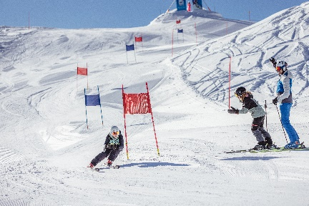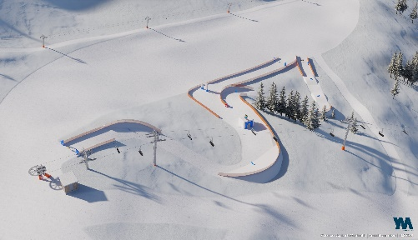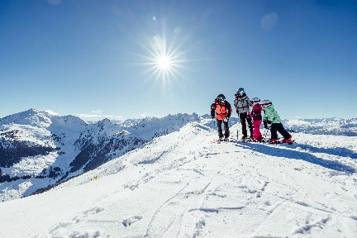

The Ski Juwel Alpbachtal Wildschönau is one of the most family-friendly ski resorts in Tyrol with 113 kilometres of pistes, 45 lifts and lots of highlights.

© Ski Juwel Alpbachtal Wildschönau

The new “KidsCross Alpbachtal” promises a varied skiing adventure for young and old.

© Young Mountain

There will be special racing areas in the area of the Galtenberglift and on the Reither Kogel.

© Ski Juwel Alpbachtal Wildschönau

**­­­­­­­­­­­**

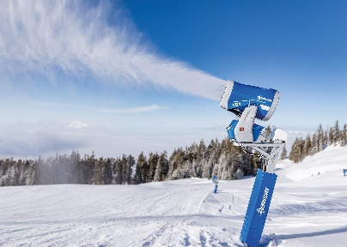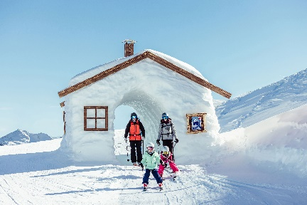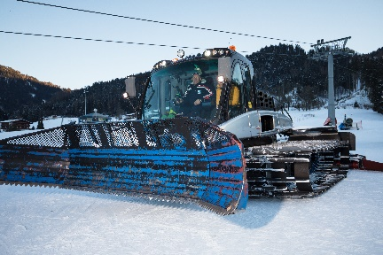

A total of 50 new tower snow guns guarantee even more efficient snowmaking in the Alpbachtal.

© Demaclenko

The numerous, multi-faceted attractions make the ski area particularly popular with families.

© Ski Juwel Alpbachtal Wildschönau

The new technical centre has space for a total of 8 snow groomers and 56 snow cannons.

© Ski Juwel Alpbachtal Wildschönau

Download more pictures via [www.skijuwel.com/sujetbilder_winter](http://www.skijuwel.com/sujetbilder_winter)

© Ski Juwel Alpbachtal Wildschönau

**Contact details**

**Ski Juwel Alpbachtal Wildschönau** 3.095 characters

Alpbach 311, 6236 Alpbach Reprint free of charge, specimen copy requested

Stefan Leitner Lisa Ainberger, MA

Head of Marketing & Sales Marketing & PR

Mobile: +43 664 8865 3249

Tel.: +43 5336 5233 609 Tel.: +43 5336 5233 641

[stefan.leitner@skijuwel.com](mailto:stefan.leitner@skijuwel.com) [lisa.ainberger@skijuwel.com](mailto:lisa.ainberger@skijuwel.com)

[www.skijuwel.com/press](http://www.skijuwel.com/press) [www.skijuwel.com/press](http://www.skijuwel.com/press)