**A day at Ski Juwel Alpbachtal Wildschönau: Pure Winter Delight**

A perfect day of skiing at Ski Juwel Alpbachtal Wildschönau begins as the first rays of sunlight illuminate the snow-covered wooden houses of the mountain villages. This unique wooden architecture of Alpbachtal and Wildschönau reflects the deep-rooted traditions of the regions. Particularly impressive is the 360° View Tower “**Top of Alpbachtal**”, a completely wooden observation tower at 2,030 meters in the ski area, clad with handcrafted shingles from Alpbach. From here, a breathtaking view unfolds over the snow-covered villages and majestic peaks.

After a cosy breakfast in one of the family-run accommodations, the day begins on the slopes. The ski region is especially family-friendly: in the specially designed **children’s areas**, young skiers learn to ski in a playful way while getting up close with the snow. While the children experience their first ski adventures, adults can enjoy the **variety of runs**. Whether beginner or advanced skier, the ski area offers the perfect slope for everyone.

A well-deserved break at one of the **rustic mountain huts** is an essential part of every ski day. Traditional specialties, such as Kaiserschmarrn from a giant pan at the Böglalm or Wildschönau pretzel soup at the Gipfö Hit on Schatzberg, bring the day to life with culinary delights. The warm atmosphere, inviting sun terraces, and stunning mountain views create a space where you can savour every moment.

In the afternoon, a romantic **horse-drawn carriage ride** through the highest village of the Kitzbühel Alps, Thierbach, is the perfect way to relax. As the snow-covered landscape glides by, the gentle snorting of the horses and the crunch of the snow create a magical sense of winter romance.

For the adventurous, the day can be topped off with a thrilling ride on one of the **certified natural toboggan runs** or a ride on the **Alpbachtaler Lauser-Sauser**. Or perhaps with an evening torch-lit hike that bathes the snowy winter landscape in a magical glow.

For those who can’t get enough of skiing, there's also the option to **hit the slopes at night**. The illuminated pistes offer a unique experience – the feeling of gliding over sparkling snow while stars twinkle in the sky is unforgettable.

A day of skiing in Ski Juwel Alpbachtal Wildschönau is more than just a sporting challenge – it’s an immersion into the Austrian way of life. The special blend of warm hospitality, unique architecture, natural experiences, and culinary delights makes this a paradise for anyone who wants to enjoy life in the moment. Whether in the winter quiet of a horse-drawn carriage ride, night skiing, or indulging in Kaiserschmarrn at a mountain hut – every moment here becomes an unforgettable experience.

DETAILS „ski juwel alpbachtal wildschönau“ www.skijuwel.com

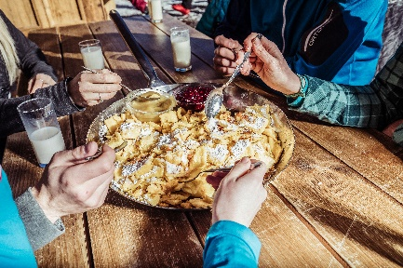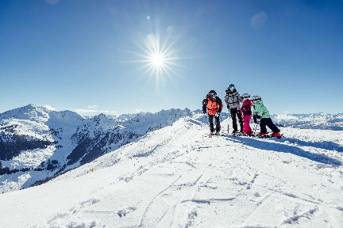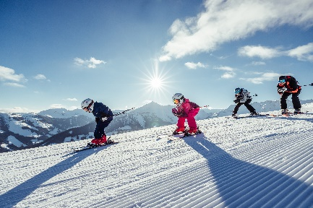

With 113 kilometres of pistes, 45 lifts and numerous attractions, Ski Juwel Alpbachtal Wildschönau is one of the most family-friendly ski areas in Tyrol.

© Ski Juwel Alpbachtal Wildschönau

The diverse range of long and wide pistes ensures unique skiing pleasure in the heart of Tyrol.

© Ski Juwel Alpbachtal Wildschönau

25 rustic huts treat you to a variety of Tyrolean specialities and regional delicacies.

© Ski Juwel Alpbachtal Wildschönau

**­­­­­­­­­­­**

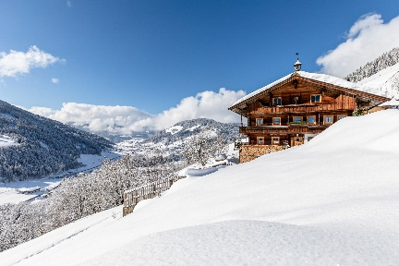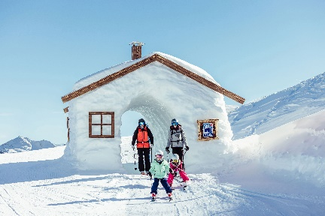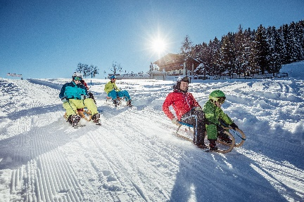

The impressive, deeply snow-covered landscape in the heart of Tyrol invites you to go winter hiking and relax.

© Ski Juwel Alpbachtal Wildschönau

The numerous, multi-faceted attractions make the ski area particularly popular with families.

© Ski Juwel Alpbachtal Wildschönau

Off-piste, a toboggan run with the whole family guarantees an unforgettable experience in the snow.

© Ski Juwel Alpbachtal Wildschönau

**Contact details**

**Ski Juwel Alpbachtal Wildschönau** 2.745 characters

Alpbach 311, 6236 Alpbach Reprint free of charge, specimen copy requested

Stefan Leitner Lisa Ainberger, MA

Head of Marketing & Sales Marketing & PR

Mobile: +43 664 8865 3249

Tel.: +43 5336 5233 609 Tel.: +43 5336 5233 641

[stefan.leitner@skijuwel.com](mailto:stefan.leitner@skijuwel.com) [lisa.ainberger@skijuwel.com](mailto:lisa.ainberger@skijuwel.com)

[www.skijuwel.com/presse](http://www.skijuwel.com/presse) [www.skijuwel.com/presse](http://www.skijuwel.com/presse)

Download more pictures via <https://www.skijuwel.com/Sujetbilder_winter>

© Ski Juwel Alpbachtal Wildschönau